

ISI-6, RIICO Institutional Area, Sitapura, Jaipur-302022, Rajasthan
Phone/Fax: 0141-2770790-92, www.pce.poornima.org

NETWORK & SHELL PROGRAMMING LAB MANUAL

(Lab Code: 244AI4-22)
4th Semester, 2nd Year

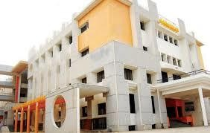

Department of Advance Computing

Session: 2025-26

TABLE OF CONTENT
S. No. | Topic/Name of Experiment | Page No.
GENERAL DETAILS
1 | Vision & Mission of Institute and Department | iii
2 | RTU Syllabus and Marking Scheme | iv
3 | Lab Outcomes and its Mapping with POs and PSOs | v - vi
4 | Rubrics of Lab | vii-viii
5 | Lab Conduction Plan | ix
6 | Lab Rotor Plan | x
7 | General Lab Instructions | xi-xii
8 | Lab Specific Safety Rules | xii
LIST OF EXPERIMENTS (AS PER RTU AUTONOMOUS SYLLABUS)
1 | Use of Basic Unix Shell Commands: ls, mkdir, rmdir, cd, cat, banner, touch, file, wc, sort, cut, grep, dd, dfspace, du, ulimit.
2 | Commands related to inode, I/O redirection and piping, process control commands, mails.
3 | Study of Different Type of LAN& Network Equipment.
4 | Study and Verification of standard Network topologies i.e. Star, Bus, Ring etc.
5 | LAN installations and Configurations.
6 | Write a program to implement various types of error correcting techniques.
7 | Write a program to implement various types of framing methods.
8 | Write two programs in C: hello_client and hello_server a. The server listens for, and accepts, a single TCP connection; it reads all the data it can from that connection, and prints it to the screen; then it closes the connection b. The client connects to the server, sends the string “Hello, world!”, then closes the connection.
9 | Write an Echo_Client and Echo_server using TCP to estimate the round-trip time from client to the server. The server should be such that it can accept multiple connections at any given time.
10 | Repeat Exercises 6 & 7 for UDP.
11 | Repeat Exercise 7 with multiplexed I/O operations.
12 | Simulate Bellman-Ford Routing algorithm in NS2.
13 | Shell Programming: Shell script based on control structure- If-then-fi, if-then else-if, nested if-else, to find: 1. Greatest among three numbers. 2. To find a year is leap year or not. 3. To input angles of a triangle and find out whether it is valid triangle or not. 4. To check whether a character is alphabet, digit or special character. 5. To calculate profit or loss.
14 | Write a shell script to print different shapes- Diamond, triangle, square, rectangle, hollow square etc.
15 | Shell Programming – Arrays.
 | Beyond the Syllabus
1 | Construct a network of hub and switch using Packet Tracer.
2 | Construct a network of Mesh topolgy using Packet Tracer.

INSTITUTE VISION & MISSION

VISION
To create knowledge based society with scientific temper, team spirit and dignity of labor to face the global competitive challenges.

MISSION
To evolve and develop skill-based systems for effective delivery of knowledge so as to equip young professionals with dedication & commitment to excellence in all spheres of life

DEPARTMENT VISION & MISSION

VISION
Become most preferred department for the latest advanced computing programs through creating appropriate teaching-learning and skill up gradation environment that fulfill current industry needs.

MISSION
- To create experiential learning environment that will enable students to compete globally in advanced computing domain. To contribute significantly to the research and the discovery of new.
- To adapt latest technological tools and contribute significantly for the advancement of knowledge in computer engineering application in industry, society and environment.
- To inculcate essential characteristic in the students for their all-round professional development, interaction with industry and society and lifelong learning.
- To create R & D infrastructure and center of excellence in various advanced computing sub domains.

RTU SYLLABUS AND MARKING SCHEME

244AI4-22: Network & Shell Programming Lab
Credit: 1 |  | Max. Marks: 100 (IA:60, ETE:40)
0L+0T+2P |  | End Term Exam: 2 Hours
S. No. | NAME OF EXPERIMENTS
1 | Use of Basic Unix Shell Commands: ls, mkdir, rmdir, cd, cat, banner, touch, file, wc, sort, cut, grep, dd, dfspace, du, ulimit.
2 | Commands related to inode, I/O redirection and piping, process control commands, mails.
3 | Study of Different Type of LAN& Network Equipment.
4 | Study and Verification of standard Network topologies i.e. Star, Bus, Ring etc.
5 | LAN installations and Configurations.
6 | Write a program to implement various types of error correcting techniques.
7 | Write a program to implement various types of framing methods.
8 | Write two programs in C: hello_client and hello_server a. The server listens for, and accepts, a single TCP connection; it reads all the data it can from that connection, and prints it to the screen; then it closes the connection b. The client connects to the server, sends the string “Hello, world!”, then closes the connection
9 | Write an Echo_Client and Echo_server using TCP to estimate the round-trip time from client to the server. The server should be such that it can accept multiple connections at any given time.
10 | Repeat Exercises 6 & 7 for UDP.
11 | Repeat Exercise 7 with multiplexed I/O operations.
12 | Simulate Bellman-Ford Routing algorithm in NS2.
13 | Shell Programming: Shell script based on control structure- If-then-fi, if-then else-if, nested if-else, to find: 1. Greatest among three numbers. 2. To find a year is leap year or not. 3. To input angles of a triangle and find out whether it is valid triangle or not. 4. To check whether a character is alphabet, digit or special character. 5. To calculate profit or loss.
14 | Write a shell script to print different shapes- Diamond, triangle, square, rectangle, hollow square etc.
15 | Shell Programming – Arrays.

EVALUATION SCHEME

I+II Mid Term Examination |  |  | Attendance and performance |  |  | End Term Examination |  |  | Total Marks
Experiment | Viva | Total | Attendance | Performance | Total | Experiment | Viva | Total
30 | 10 | 40 | 10 | 30 | 40 | 30 | 10 | 40 | 100

DISTRIBUTION OF MARKS FOR EACH EXPERIMENT

Attendance | Record | Performance | Total
2 | 3 | 5 | 10

LAB OUTCOME AND ITS MAPPING WITH PO & PSO

LAB OUTCOMES
After completion of this course, students will be able to –

243AI4-23.1 | To understand, identify, and work with various types of local area networks (LANs), standard network equipment, and network topologies such as star, bus, and ring.
243AI4-23.2 | To develop practical skills for LAN installation, configuration, and verification, ensuring students can design and deploy efficient and reliable network infrastructures.
243AI4-23.3 | To apply programming knowledge for implementing error correction techniques, framing methods, and client-server socket communication using TCP and UDP protocols.
243AI4-23.4 | To provide experience with network simulation tools (such as NS2) and Unix-based system commands, enhancing students’ ability to analyze, troubleshoot, and manage network systems and processes effectively.

LO-PO-PSO MAPPING MATRIX OF COURSE

LO/PO/PSO | PO1 | PO2 | PO3 | PO4 | PO5 | PO6 | PO7 | PO8 | PO9 | PO10 | PO11 | PO12 | PSO1 | PSO2 | PSO3
243AI4-23.1 | - | - | - | - | - | - | - | - | - | - | - | - | 2 | - | -
243AI4-23.2 | - | 2 | - | - | - | - | - | - | - | - | - | - | 2 | - | -
243AI4-23.3 | - | - | 2 | - | - | - | - | - | - | - | - | - | - | 2 | -
243AI4-23.4 | - | - | 2 |  | - | - | - | - | - | - | - | - | 2 | - | 2

PROGRAM OUTCOMES (POs)

PO1 | Engineering knowledge: Apply the knowledge of mathematics, science, engineering fundamentals and an engineering specialization to the solution of complex engineering problems
PO2 | Problem analysis: Identify, formulate, review research literature, and analyze complex engineering problems reaching substantiated conclusions using first principles of mathematics, natural sciences, and engineering sciences.
PO3 | Design/development of solutions: Design solutions for complex engineering problems and design system components or processes that meet the specified needs with appropriate consideration for the public health and safety, and the cultural, societal, and environmental considerations.
PO4 | Conduct investigations of complex problems: Use research-based knowledge and research methods including design of experiments, analysis and interpretation of data, and synthesis of the information to provide valid conclusions.
PO5 | Modern tool usage: Create, select, and apply appropriate techniques, resources, and modern engineering and IT tools including prediction and modeling to complex engineering activities with an understanding of the limitations.
PO6 | The engineer and society: Apply reasoning informed by the contextual knowledge to assess societal, health, safety, legal and cultural issues and the consequent responsibilities relevant to the professional engineering practice.
PO7 | Environment and sustainability: Understand the impact of the professional engineering solutions in societal and environmental contexts, and demonstrate the knowledge of, and need for sustainable development.
PO8 | Ethics: Apply ethical principles and commit to professional ethics and responsibilities and norms of the engineering practice.
PO9 | Individual and team work: Function effectively as an individual, and as a member or leader in diverse teams, and in multidisciplinary settings.
PO10 | Communication: Communicate effectively on complex engineering activities with the engineering community and with society at large, such as, being able to comprehend and write effective reports and design documentation, make effective presentations, and give and receive clear instructions.
PO11 | Project management and finance: Demonstrate knowledge and understanding of the engineering and management principles and apply these to one’s own work, as a member and leader in a team, to manage projects and in multidisciplinary environments.
PO12 | Life-long learning: Recognize the need for, and have the preparation and ability to engage in independent and life-long learning in the broadest context of technological change.

PROGRAM SPECIFIC OUTCOMES (PSOs)

PSO1 | Apply core concepts and techniques of artificial intelligence and data science to analyze complex datasets, extract meaningful insights, and develop intelligent systems for real-world applications, while demonstrating effective teamwork and leadership with collaborative problem-solving abilities.
PSO2 | Demonstrate the ability to collect, process, analyze, and interpret large-scale data using modern tools and technologies to support data-driven decision-making for sustainable solutions.
PSO3 | Exhibit the capability to design and develop solutions for varied application domains through self and lifelong learning abilities along with following professional ethics, responsibility and awareness of societal and environmental impacts when working with AI and data-driven technologies ensuring privacy, fairness, and transparency.

RUBRICS FOR LAB
Laboratory Evaluation Rubrics:

S.  No. | Crit eria | Sub Criteria and Marks Distribution |  |  | Outstanding (>90%) | Admirable (70-90%) | Average (40-69%) | Inadequate (<40%)
 |  | Mid-Term | End-Team | Continues Evaluation
A | PERFORMANCE (PO1, PO8, PO9) | Procedure Followed  M.M. 100 = 6 | Procedure Followed  M.M. 100 = 6 | Procedure Followed  M.M. 100 = 2 | - All possible system and Input/ Output variables are taken into account  - Performance measures are properly defined  - Experimental scenarios are very well defined | - Most of the system and Input/ Output variables are taken into account  - Most of the Performance measures are properly defined  - Experimental scenarios are defined correctly | - Some of the system and Input/ Output variables are taken into account  - Some of the Performance measures are properly defined  - Experimental scenarios are defined but not sufficient | - System and Input/ Output variables are not defined  - Performance measures are not properly defined • Experimental scenarios not defined
 |  | Individual/Tea m Work  M.M. 100 = 6 | Individual/Tea m Work  M.M. 100 = 6 | Individual/Tea m Work  M.M. 100 = 2 | - Coordination among the group members in performing the experiment was excellent | - Coordination among the group members in performing the experiment was good | - Coordination among the group members in performing the experiment was average | - Coordination among the group members in performing the experiment was very poor
 |  | Precision in data collection  M.M. 100 = 6 | Precision in data collection  M.M. 100 = 6 | Precision in data collection  M.M. 100 = 4 | - Data collected is correct in size and from the experiment performed | - Data collected is appropriate in size and but not from proper sources. | - Data collected is not so appropriate in size and but from proper sources. | - Data collected is neither appropriate in size and norfrom proper sources
B | LAB RECORD/WRITTEN WORK (PO1, PO8, PO10) | NA | NA | Timing of Evaluation of Experiment  M.M. 100 = 6 | - On the Same Date of Performance | - On the Next Turn from Performance | - Before Dead Line | - On the Dead Line
 |  | Data Analysis  M.M. 100 = 6 | Data Analysis  M.M. 100 = 6 | Data Analysis  M.M. 100 = 4 | - Data collected is exhaustively analyzed & appropriate features are selected | - Data collected is analyzed & but appropriate features are not selected | - Data collected is not analyzed properly. •Features selected are not appropriate | - Data collected is not analyzed & the features are not selected

 |  | Results and Discussion  M.M. 100 = 6 | Results and Discussion  M.M. 100 = 6 | Results and Discussion  M.M. 100 = 4 | - All results are very well presented with all variables  - Well prepared neat diagrams/plots/ tables for all performance measured  - Discussed critically behavior of the system with reference to performance measures  - Very well discussed pros n cons of outcome | - All results presented but not all variables mentioned  - Prepared diagrams /plots/ tables for all performance measured but not so neat  - Discussed behavior of the system with reference to performance measures but not critical  - Discussed pros n cons of outcome in brief | - Partial results are included  - Prepared diagrams /plots/ tables partially for the performance measures  - Behavior of the system with reference to performance measures has been superficially presented  - Discussed pros n cons of outcome but not so relevant | - Results are included but not as per experimental scenarios  - No proper diagrams /plots/ tables are prepared  - Behavior of the system with reference to performance measures has not been presented  - Did not discuss pros n cons of outcome
C | VIVA (PO1, PO10) | Way of presentation  M.M. 100 = 5 | Way of presentation  M.M. 100 = 5 | Way of presentation  M.M. 100 = 4 | - Presentation was very good | - Presentation was good | - Presentation was satisfactory | - Presentation was poor
 |  | Concept Explanation  M.M. 100 = 5 | Concept Explanation  M.M. 100 = 5 | Concept Explanation  M.M. 100 = 4 | - Conceptual explanation was excellent | - Conceptual explanation was good | - Conceptual explanation was somewhat good | - Conceptual explanation was Poor
D | ATTENDA NCE | NA | NA | Attendance  M.M. 100 =10 | - Present more than 90% of lab sessions | - Present more than 75% of lab sessions | - Present more than 60% of lab sessions | - Present in less than 60% lab sessions

LAB CONDUCTION PLAN

Total number of Experiments –15
Total numbers of turns required - 15

Experiment Number | Scheduled Week
Experiment -1 | Week 1
Experiment -2 | Week 2
Experiment -3 | Week 3
Experiment -4 | Week 4
Experiment -5 | Week 5
Experiment -6 | Week 6
Experiment -7 | Week 7
I Mid Term | Week 8
Experiment -8 | Week 9
Experiment-9 | Week 10
Experiment-10 | Week 11
Experiment-11 | Week 12
Experiment-12 | Week 13
Experiment-13 | Week 14
II Mid Term | Week 15

DISTRIBUTION OF LAB HOURS

S. No. | Activity | Distribution of Lab Hours
 |  | Time (180 minute) | Time (120 minute)
1 | Attendance | 5 | 5
2 | Explanation of Experiment & Logic | 30 | 30
3 | Performing the Experiment | 60 | 30
4 | File Checking | 40 | 20
5 | Viva/Quiz | 30 | 20
6 | Solving of Queries | 15 | 15

LAB ROTAR PLAN ROTOR-1
Ex. No. | NAME OF EXPERIMENTS
1 | Zero Lab
2 | Study of Different Type of LAN & Network Equipments.
3 | Study and Verification of standard Network topologies i.e. Star, Bus, Ring etc.
4 | LAN installations and Configurations.
5 | Write a program to implement various types of error correcting techniques.
6 | Write a program to implement various types of framing methods.
7 | Write two programs in C: hello_client and hello_server  a. The server listens for, and accepts, a single TCP connection; it reads all  the data it can from that connection, and prints it to the screen; then it  closes the connection  b. The client connects to the server, sends the string “Hello, world!”, then  closes the connection
8 | Repeat Exercises 6 & 7 for UDP.
9 | Repeat Exercise 7 with multiplexed I/O operations.
ROTOR-2

Ex. No. | NAME OF EXPERIMENTS
10 | Simulate Bellman-Ford Routing algorithm in NS2.
11 | Use of Basic Unix Shell Commands: ls, mkdir, rmdir, cd, cat, banner, touch, file, wc, sort, cut, grep, dd, dfspace, du, ulimit.
12 | Commands related to inode, I/O redirection and piping, process control commands, mails.
13 | Shell Programming: Shell script based on control structure- If-then-fi, if-then else-if, nested if-else, to find: 1. Greatest among three numbers. 2. To find a year is leap year or not. 3. To input angles of a triangle and find out whether it is valid triangle or not. 4. To check whether a character is alphabet, digit or special character. 5. To calculate profit or loss.
14 | Write a shell script to print different shapes- Diamond, triangle, square, rectangle, hollow square etc.
15 | Shell Programming – Arrays.
16 | Construct a network of hub and switch using Packet Tracer. (Beyond Syllabus)
17 | Construct a network of Bus, star topolgy using Packet Tracer. (Beyond Syllabus)

GENERAL LAB INSTRUCTIONS
DO’S
- Enter the lab on time and leave at proper time.
- Wait for the previous class to leave before the next class enters.
- Keep the bag outside in the respective racks.
- Utilize lab hours in the corresponding.
- Turn off the machine before leaving the lab unless a member of lab staff has specifically told you not to do so.
- Leave the labs at least as nice as you found them.
- If you notice a problem with a piece of equipment (e.g., a computer doesn't respond) or the room in general (e.g., cooling, heating, lighting) please report it to lab staff immediately. Do not attempt to fix the problem yourself.

DON’TS
- Don't abuse the equipment.
- Do not adjust the heat or air conditioners. If you feel the temperature is not properly set, inform lab staff; we will attempt to maintain a balance that is healthy for people and machines.
- Do not attempt to reboot a computer. Report problems to lab staff.
- Do not remove or modify any software or file without permission.
- Do not remove printers and machines from the network without being explicitly told to do so by lab staff.
- Don't monopolize equipment. If you're going to be away from your machine for more than 10 or 15 minutes, log out before leaving. This is both for the security of your account, and to ensure that others are able to use the lab resources while you are not.
- Don’t use internet, internet chat of any kind in your regular lab schedule.
- Do not download or upload of MP3, JPG or MPEG files.
- No games are allowed in the lab sessions.
- No hardware including USB drives can be connected or disconnected in the labs without prior permission of the lab in-charge.
- No food or drink is allowed in the lab or near any of the equipment. Aside from the fact that it leaves a mess and attracts pests, spilling anything on a keyboard or other piece of computer equipment could cause permanent, irreparable, and costly damage. (and in fact has) If you need to eat or drink, take a break and do so in the canteen.
- Don’t bring any external material in the lab, except your lab record, copy and books.
- Don’t bring the mobile phones in the lab. If necessary, then keep them in silence mode.
- Please be considerate of those around you, especially in terms of noise level. While labs are a natural place for conversations of all types, kindly keep the volume turned down.
- If you are having problems or questions, please go to either the faculty, lab in-charge or the lab supporting staff. They will help you. We need your full support and cooperation for smooth functioning of the lab.

LAB SPECIFIC SAFETY RULES

Before entering in the lab

- All the students are supposed to prepare the theory regarding the next experiment/ Program.
- Students are supposed to bring their lab records as per their lab schedule.
- Previous experiment/program should be written in the lab record.
- If applicable trace paper/graph paper must be pasted in lab record with proper labeling.
- All the students must follow the instructions, failing which he/she may not be allowed in
the lab.

While working in the lab

- Adhere to experimental schedule as instructed by the lab in-charge/faculty.
- Get the previously performed experiment/ program signed by the faculty/ lab in charge.
- Get the output of current experiment/program checked by the faculty/ lab in charge in the
Lab copy.
- Each student should work on his/her assigned computer at each turn of the lab.
- Take responsibility of valuable accessories.

Zero Lab

Introduction about Lab

Software Required
Turbo C, Linux, Packet Tracer

Socket
Sockets allow communication between two different processes on the same or different machines. To be more precise, it's a way to talk to other computers using standard Unix file descriptors. In Unix, every I/O action is done by writing or reading a file descriptor. A file descriptor is just an integer associated with an open file and it can be a network connection, a text file, a terminal, or something else.
To a programmer, a socket looks and behaves much like a low-level file descriptor. This is because commands such as read() and write() work with sockets in the same way they do with files and pipes.
Sockets were first introduced in 2.1BSD and subsequently refined into their current form with 4.2BSD. The sockets feature is now available with most current UNIX system releases

Where is Socket Used?
A Unix Socket is used in a client-server application framework. A server is a process that performs some functions on request from a client. Most of the application-level protocols like FTP, SMTP, and POP3 make use of sockets to establish connection between client and server and then for exchanging data.

Socket Types
There are four types of sockets available to the users. The first two are most commonly used and the last two are rarely used.
Processes are presumed to communicate only between sockets of the same type but there is no restriction that prevents communication between sockets of different types.

•Stream Sockets − Delivery in a networked environment is guaranteed. If you send through the stream socket three items "A, B, C", they will arrive in the same order − "A, B, C". These sockets use TCP (Transmission Control Protocol) for data transmission. If delivery is impossible, the sender receives an error indicator. Data records do not have any boundaries.
•Sockets − Delivery in a networked environment is not guaranteed. They're connectionless because you don't need to have an open connection as in Stream Sockets − you build a packet with the destination information and send it out. They use UDP (User Datagram Protocol).

•Raw Sockets − These provide users access to the underlying communication protocols, which support socket abstractions. These sockets are normally datagram oriented, though their exact characteristics are dependent on the interface provided by the protocol. Raw sockets are not intended for the general user; they have been provided mainly for those interested in developing new communication protocols, or for gaining access to some of the more cryptic facilities of an existing protocol.
•Sequenced Packet Sockets − They are similar to a stream socket, with the exception that record boundaries are preserved. This interface is provided only as a part of the Network Systems (NS) socket abstraction, and is very important in most serious NS applications. Sequenced-packet sockets allow the user to manipulate the Sequence Packet Protocol (SPP) or Internet Datagram Protocol (IDP) headers on a packet or a group of packets, either by writing a prototype header along with whatever data is to be sent, or by specifying a default header to be used with all outgoing data, and allows the user to receive the headers on incoming packets.

Unix Socket - Client Server Model
Most of the Net Applications use the Client-Server architecture, which refers to two processes or two applications that communicate with each other to exchange some information. One of the two processes act as a client process, and another process acts as a server.

Client Process
This is the process, which typically makes a request for information. After getting the response, this process may terminate or may do some other processing.
Example, Internet Browser works as a client application, which sends a request to the Web Server to get one HTML webpage.

Server Process
This is the process which takes a request from the clients. After getting a request from the client, this process will perform the required processing, gather the requested information, and send it to the client. Once done, it becomes ready to serve another client. Server processes are always alert and ready to serve incoming requests.
Example − Web Server keeps waiting for requests from Internet Browsers and as soon as it gets any request from a browser, it picks up a requested HTML page and sends it back to that Browser.
Note that the client needs to know the address of the server, but the server does not need to know the address or even the existence of the client prior to the connection being established. Once a connection is established, both sides can send and receive information.

Architectures
There are two types of client-server architectures −
•2-tier architecture − In this architecture, the client directly interacts with the server. This type of architecture may have some security holes and performance problems. Internet Explorer and Web Server work on two-tier architecture. Here security problems are resolved using Secure Socket Layer (SSL).

•3-tier architectures − In this architecture, one more software sits in between the client and the server. This middle software is called ‘middleware’. Middleware are used to perform all the security checks and load balancing in case of heavy load. A middleware takes all requests from the client and after performing the required authentication, it passes that request to the server. Then the server does the required processing and sends the response back to the middleware and finally the middleware passes this response back to the client. If you want to implement a 3-tier architecture, then you can keep any middleware like Web Logic or WebSphere software in between your Web Server and Web Browser.

Types of Server
There are two types of servers you can have −
•Iterative Server − This is the simplest form of server where a server process serves one client and after completing the first request, it takes request from another client. Meanwhile, another client keeps waiting.
•Concurrent Servers − This type of server runs multiple concurrent processes to serve many requests at a time because one process may take longer and another client cannot wait for so long. The simplest way to write a concurrent server under Unix is to fork a child process to handle each client separately.

EXPERIMENT-1

OBJECTIVE
To study of different type of LAN &Network Equipment’s.
Local Area Network (LAN)
We’re confident that you’ve heard of these types of networks before – LANs are the most frequently discussed networks, one of the most common, one of the most original and one of the simplest types of networks. LANs connect groups of computers and low-voltage devices together across short distances (within a building or between a group of two or three buildings in close proximity to each other) to share information and resources. Enterprises typically manage and maintain LANs.
Using routers, LANs can connect to wide area networks (WANs, explained below) to rapidly and safely transfer data.

Metropolitan Area Network (MAN)

These types of networks are larger than LANs but smaller than WANs – and incorporate elements from both types of networks. MANs span an entire geographic area (typically a town or city, but sometimes a campus). Ownership and maintenance is handled by either a single person or company (a local council, a large company, etc.).

Wide Area Network (WAN)

Slightly more complex than a LAN, a WAN connects computers together across longer physical distances. This allows computers and low-voltage devices to be remotely connected to each other over one large network to communicate even when they’re miles apart.
The Internet is the most basic example of a WAN, connecting all computers together around the world. Because of a WAN’s vast reach, it is typically owned and maintained by multiple administrators or the public.
Different Networking Equipment —

Network Hub:

Network Hub is a networking device which is used to connect multiple network hosts. A network hub is also used to do data transfer. The data is transferred in terms of packets on a computer network. So when a host sends a data packet to a network hub, the hub copies the data packet to all of its ports connected to. Like this, all the ports know about the data and the port, for whom the packet is intended, claims the packet.

However, because of its working mechanism, a hub is not so secure and safe. Moreover, copying the data packets on all the interfaces or ports makes it slower and more congested which led to the use of network switch.

Network Switch:

Like a hub, a switch also works at the layer of LAN (Local Area Network) but you can say that a switch is more intelligent than a hub. While hub just does the work of data forwarding, a switch does 'filter and forwarding' which is a more intelligent way of dealing with the data packets.

So, when a packet is received at one of the interfaces of the switch, it filters the packet and sends only to the interface of the intended receiver. For this purpose, a switch also maintains a CAM (Content Addressable Memory) table and has its own system configuration and memory. CAM table is also called as forwarding table or forwarding information base (FIB).

Modem:

A Modem is somewhat a more interesting network device in our daily life. So if you have noticed around, you get an internet connection through a wire (there are different types of wires) to your house. This wire is used to carry our internet data outside to the internet world.
However, our computer generates binary data or digital data in forms of 1s and 0s and on the other hand, a wire carries an analog signal and that's where a modem comes in.
A modem stands for (Modulator+Demodulator). That means it modulates and demodulates the signal between the digital data of a computer and the analog signal of a telephone line.

Network Router:

A router is a network device which is responsible for routing traffic from one to another network. These two networks could be a private company network to a public network. You can think of a router as a traffic police who directs different network traffic to different directions.

Bridge:

If a router connects two different types of networks, then a bridge connects two subnetworks as a part of the same network. You can think of two different labs or two different floors connected by a bridge.

Repeater:

A repeater is an electronic device that amplifies the signal it receives. In other terms, you can think of repeater as a device which receives a signal and retransmits it at a higher level or higher power so that the signal can cover longer distances.
For example, inside a college campus, the hostels might be far away from the main college where the ISP line comes in. If the college authority wants to pull a wire in between the hostels and main campus, they will have to use repeaters if the distance is much because different types of cables have limitations in terms of the distances they can carry the data for.

When these network devices take a particular configurational shape on a network, their configuration gets a particular name and the whole formation is called Network topology. In certain circumstances when we add some more network devices to a network topology, its called Daisy chaining.

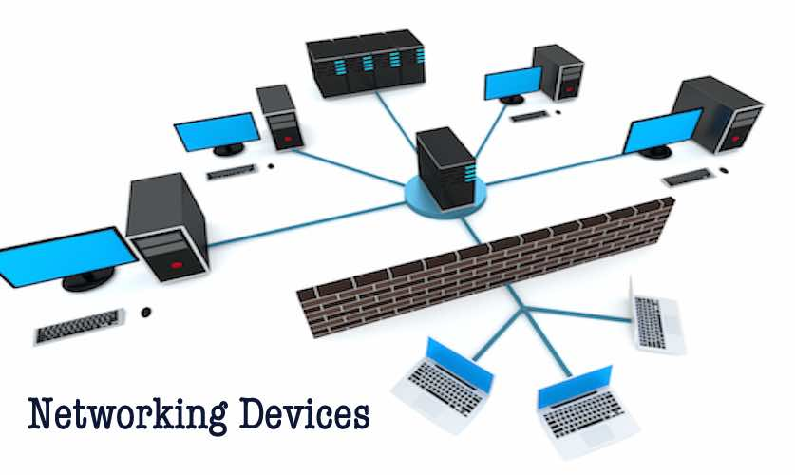
Figure 1: Different network equipment

Viva Questions:
- Differentiate between Hub, Switch and Router.
- Differentiate between Router and Gateway.
- What is Broadcast domain and Collision domain?
- Compare Hub and Switch with respect to Broadcast domain and Collision domain?
- How does Switch perform forwarding function.

EXPERIMENT-2

OBJECTIVE

Study and Verification of standard Network topologies i.e. Star, Bus, Ring etc.

Network Topologies:

LAN physical topology defines the geographical arrangement of networking devices. Topologies are driven fundamentally by two network connection types. A point-to-point connection is a direct link between two devices. For example, when you attach your computer to a printer, you have created a point-to-point link. In networking terms, most of the today’s point-to-point connections are associated with modems and PSTN (Public Switched Telephone Network) communications because only two devices share point-to-point connections, it defeats the purpose of a shared network.

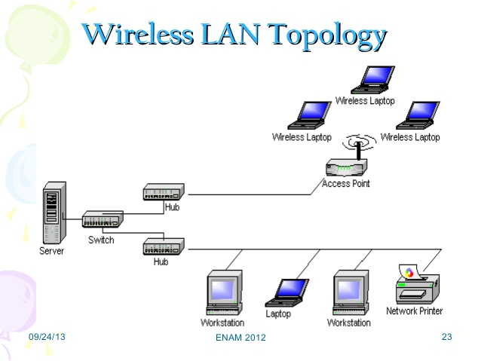
Figure 2: Pictorial Description of LAN Topology

The major topologies of LAN are:

Bus Topology:

The physical bus topology is the simplest and most widely used of the network designs. It consists of one continuous length of cabling (trunk) and a terminating resistor (terminator) at each end. The data communications message travels along the bus in both directions until it is picked up by a workstation or server NIC.

If the message is missed or not recognized, it reaches the end of the cabling and dissipates at the terminator. All nodes in the bus topology have equal access to the trunk no discriminating here. This is accomplished using short drop cables or direct T-connectors.
This design is easy to install because the backbone trunk traverses the LAN as one cable segment. This minimizes the amount of transmission media required. Also, the number of devices and length of the trunk can be easily expanded. Advantages of Bus Topology: It uses established standards and it is relatively easy to install.

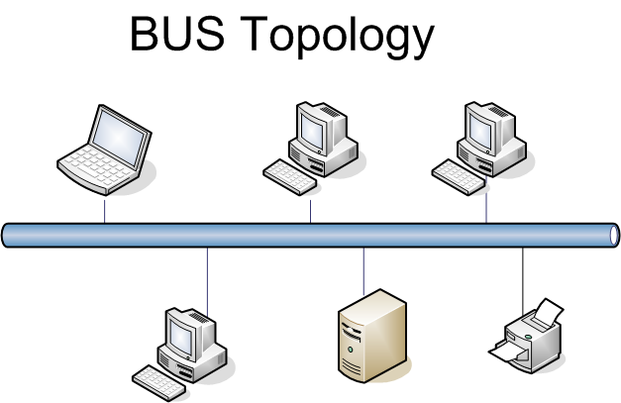

Advantages of Bus Topology:

- It uses established standards and it is relatively easy to install.
- It requires fewer media than other topologies.

Disadvantages of Bus Topology:

- The bus networks are difficult to reconfigure, especially when the acceptable number of connections or maximum distances have been reached.
- They are also difficult to troubleshoot because everything happens on a single media segment. This can have dangerous consequences because any break in the cabling brings the network to its knees.

Ring Topology

As its name implies, the physical ring topology is a circular loop of point-to-point links. Each device connects directly or indirectly to the ring through an interface device or drop cable. Messages travel around the ring from node to node in very organized manner. Each workstation checks the messages for a matching destination address.
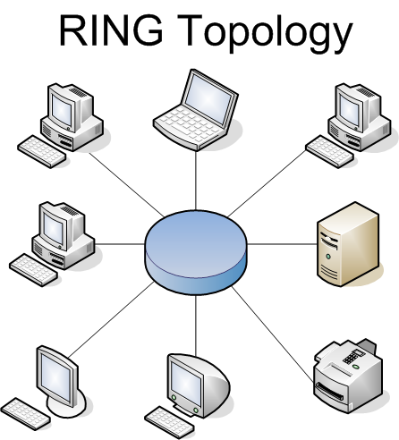
If the address doesn’t match, the node simply regenerates the message and sends it on its way. If the address matches, the node accepts the message and sends a reply to the originating sender. Initially, ring topologies are moderately simple to install; however, they require more media than bus systems because the loop must be closed. Once your ring has been installed, it’s a bit more difficult to reconfigure. Ring segments must be divided or replaced every time they are changed. Moreover, any break in the loop can affect all devices on the network.

Advantages of Ring Topology:

- They are very easy to troubleshoot because each device incorporates a repeater.
- A special internal feature called becoming, allows the troubled workstation to identify them quickly.

Disadvantages of Ring Topology:

- It is considerably difficult to install and reconfigure ring topology.
- Media failure on unidirectional or single loop causes complete network failure.

Star Topology:

The Physical star topology uses a central controlling hub with dedicated legs pointing in all directions like points of a star. Each network devices has a dedicated point-to-point link to the central hub. This strategy prevents troublesome collisions and keeps the line of communication open and free of traffic.
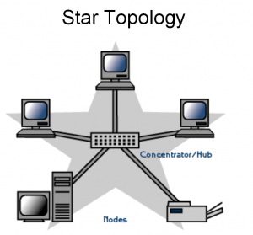

Star topologies are somewhat difficult to install because each device gets its own dedicated segment. Obviously, they require a great deal of cabling. This design provides an excellent platform for reconfiguration and troubleshooting.</p><p>Changes to the network are as simple as plugging another segment into the hub. In addition, a break in the LAN is easy to isolate and doesn’t affect the rest of the network.

Advantages of Star Topology:

- Relatively easy to configure.
- Easy to troubleshoot.
- Media faults are automatically isolated to the failed segment.

Disadvantages of Star Topology:

- Requires more cable than most topologies.
- Moderately difficult to install.

Mesh Topology

The mesh topology is the only true point-to-point design. It uses a dedicated link between every device on the network. This design is not very practical because of its excessive waste of transmission media. This topology is difficult to install and reconfigure.
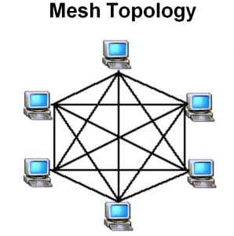

Moreover, as the number of devices increases geometrically, the speed of communication also becomes slow. ATM (Asynchronous Transfer Mode) and switched Hubs are the example of high-speed Mesh implementation.

Advantages of Mesh Topology:

- Easy to troubleshoot because each link is independent of all others.
- You can easily identify faults and isolate the affected links.
- Because of the high number of redundant paths, multiple links can fail before the failure affects any network device.

Disadvantages of Mesh Topology:

It is difficult to install and reconfigure especially as the number of devices increases.

Viva Questions
- How many ports and cable links are required for a star topology?
- For n devices in a network, what is the number of cable links required for a mesh, ring, bus topology.
- What happens if a connection fails for devices arranged in a Mesh topology?
- What is the consequence if connection fails for devices arranged in a Ring topology?
- What occurs when a connection fails in a Star topology?

EXPERIMENT- 3

OBJECTIVE
LAN installations and Configurations.

Installation:
Count the number of computers you need to hardwire
When setting up a LAN, you'll need to know how many computers will be connecting to the network via Ethernet. This will determine the number of ports you'll need.
If you have four or fewer computers that you need to hardwire, you'll just need a router. If you have more than four, you'll likely need to get a switch to extend the number of ports available on your router.

Decide if you want to create a wireless network

If you want to allow devices to connect wirelessly, you'll need a router that can broadcast a wireless network. Most routers you'll find at the store or online have wireless capabilities.
Network switches do not allow wireless devices to connect, and can only be used for hardwired LANs or to extend the number of ports available to the router.

Determine if you want all network devices to have internet access

If you want all of the connected devices to have access to the internet, you'll need a router to handle the connections. If you don't need the devices to have a network connection, you can just use a network switch.

Measure the distances for all hardwired devices

This isn't much of an issue in most homes, but network cables cannot run longer than 100m (328 ft). If you have to run cable farther than this, you'll need switches in between.

Gather your network hardware

To create a LAN, you'll need a router or switch, which will act as the hub of your network. These devices route information to the correct computers.

A router will automatically handle assigning IP addresses to each device on the network, and is necessary if you intend to share your internet connection with all the connected devices. It is highly recommended that you build your network with a router, even if you're not sharing an internet connection.

A network switch is like a simpler version of a router. It will allow connected devices to talk to each other, but will not automatically assign IP addresses and will not share an internet connection. Switches are best used to expand the number of LAN ports available on the network, as they can be connected to the router.
Set up your router

You don't need to do much to set up a router for a basic LAN. Just plug it into a power source, preferably close to your modem if you plan on sharing the internet connection through it.

Connect your modem to your router (if necessary)

If you're sharing the internet connection from your modem, connect the modem to the WAN/INTERNET port on the router. This is usually a different color from the other ports.

Connect your switch to your router (if necessary).

If you're using a switch to expand the number of ports available on the router, plug an Ethernet cable into any LAN port on the router and any LAN port on the switch. This will expand the network to the rest of the LAN ports on the switch.

Connect your computers to open LAN ports

Use Ethernet cables to connect each computer to an open LAN port on your router or switch. It doesn't matter what order the ports are connected in. Ethernet cables cannot reliably transfer data at lengths larger than 100m (328 ft).

Setup one PC as a DHCP server if you're just using a switch

If you're only using a switch as your network hub, setting up one computer as a DHCP (Dynamic Host Configuration Protocol) server will allow all of the connected computers to easily obtain IP addresses.
You can quickly create a DHCP server on one of your computers by installing a third-party utility.
The rest of the computers on the network will obtain IP addresses automatically once the server is running, as long as they are set to do so.

Verify the network connection on each computer
After each computer obtains an IP address, they'll be able to talk to each other on the network. If you're using a router to share your internet connection, each computer will be able to access the internet.

Verify the network connection on each computer

After each computer obtains an IP address, they'll be able to talk to each other on the network. If you're using a router to share your internet connection, each computer will be able to access the internet.

Set up file and printer sharing

Once your network is up, you won't see anything on other computers unless that computer has shared files. You can designate files, folders, drives, printers, and other devices as shared so that anyone on the network, or just specific users, can access them.

Set up your router

When you're setting up a wireless router, you'll need to keep a few things in mind: For easy troubleshooting, the router should usually be placed close to your modem. It should be located centrally to allow for maximum wireless coverage. You'll need to connect a computer to the router via Ethernet during the setup process.

Plug a computer into one of the router's LAN ports

You'll be using your computer's web browser to configure the router's wireless network.
Type in the router's IP address

You can typically find this printed on the bottom of the router, or in your router's documentation. If you can't find it, there are a couple things you can try:
Windows - Right-click the Network button in the System Tray → click Open Network and Sharing Center → click the Ethernet link → click Details → find the Default Gateway entry for your router's IP address.
Mac - Click the Apple menu and select System Preferences → click Network → click your Ethernet connection → find the Router entry for your router's IP address.

Log in with the administrator account

You'll be prompted for the login information for your router. The default login information varies depending on your router model, but the username is often "admin" and the password is often "admin," "password," or blank.
You can look up your router model at https://portforward.com/router-password/ to find the default login information.
Open the Wireless section of the router settings. The exact location and wording of this section varies from router to router.
Change the name of your network in the SSID field. This may also be called "Network name." This is the name that appears in the list of available wireless networks.
Select WPA2-Personal as the Authentication or Security option. This is the most secure option currently available on most routers. Avoid WPA and WEP except when explicitly required by older, incompatible devices.

Ensure the wireless network is enabled

Depending on the router, you may have to check a box or click a button at the top of the Wireless menu to enable the wireless network.
Configuration:
Determine the number of computers you want to connect

The number of computers you're connecting will determine the type of network hardware you'll need. If you are connecting four or less computers, you'll just need a single router, or one switch if you don't need internet. If you're connecting more than four computers, you'll want a router and a switch, or just a switch if you don't need internet.

Determine your network layout

If you’re installing a permanent LAN solution, you'll want to keep cable length in mind. CAT5 Ethernet cables should not run longer than 250 feet. If you need to cover larger distances, you'll need switches at regular intervals, or you'll need to use CAT6 cables.
You'll need one Ethernet cable for each computer you want to connect to the LAN, as well as an Ethernet cable to connect the router to the switch (if applicable).

Obtain the network hardware

To create a LAN, you'll need a router and/or a network. These pieces of hardware are the "hub" of your LAN, and all of your computers will be connected to them.
The easiest way to create a LAN where every computer has access to the internet is to use a router, and then add a network switch if the router doesn't have enough ports. A router will automatically assign an IP address to every computer that is connected to it.
Switches are similar to routers but do not automatically assign IP addresses. Switches typically have many more Ethernet ports than a router has.

Connect your modem to the WAN port on the router

This port may be labeled "INTERNET" instead. This will provide internet access to every computer that is connected to your LAN.
You can skip this if you're setting up a LAN without internet access. You don't need a router at all to create a LAN, but it makes things easier. If you just use a network switch, you'll need to manually assign IP addresses to each computer after connecting them.

Connect the switch to a LAN port on the router

If you're using a network switch to connect more computers, connect it to one of the LAN ports on the router. You can use any open port on the switch to make the connection. When connected, the router will provide IP addresses for every computer that is connected to either device.

Find the Ethernet port on your PC

You can usually find this on the back of your desktop tower, or along the side or back of a laptop. Slim laptops may not have an Ethernet port, in which case you'll need to either use a USB Ethernet adapter or connect wirelessly if your router allows it.

Plug one end of an Ethernet cable into your computer

Make sure you're using an Ethernet cable (RJ45), not a telephone cable (RJ11).
Plug the other end of the cable into an open LAN port

This can be any open LAN port on either the router or the switch, depending on your LAN setup.

Test out your network (router only)

If you're using a router, your work is complete. Once all of the computers are connected to a LAN port, they will be assigned IPs automatically and will appear on the network. If you set up your LAN for gaming, you should be able to start your LAN game and have each computer connect. If you're using a switch and no router, you'll still need to assign IP addresses to each computer.

Right-click on your network connection

You'll see this in your System Tray. If you are connecting your computers through a switch with no router, you'll need to assign each computer on the network its own individual IP address. This process is handled automatically if you're using a router.

Think of an IP address as a mailing address. Each computer on the network needs a unique IP address so that information sent across the network reaches the correct destination.

Click Open Network and Sharing Center

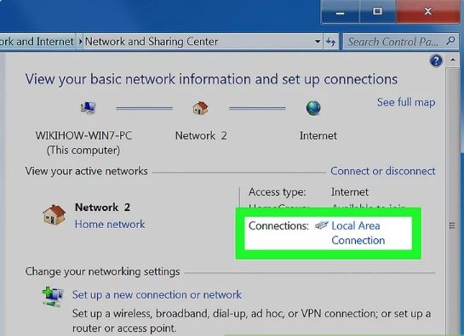

Click the Ethernet link at the top of the window. You'll see this next to "Connections."

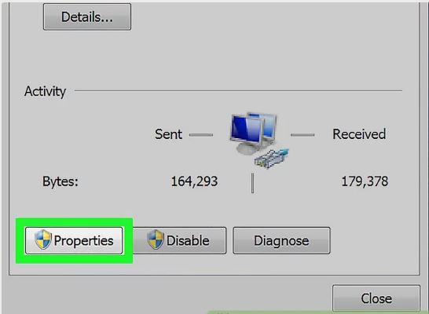

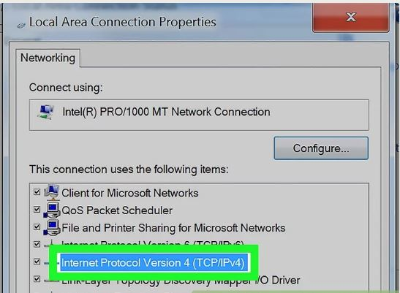

Click Internet Protocol Version 4 (TCP/IPv4).

Make sure you don't uncheck it, just highlight it.

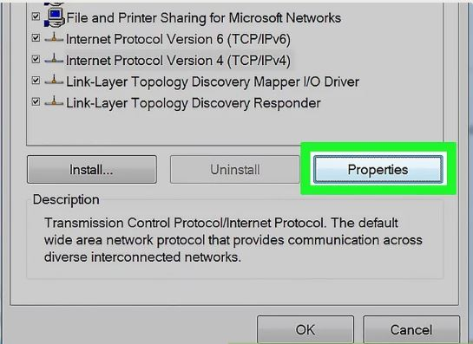

Click Properties.
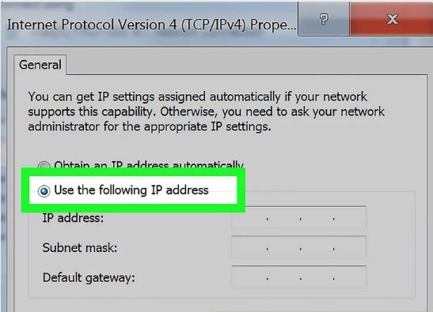

Click the Use the following IP address radio button.

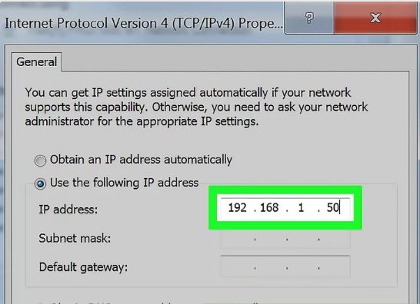

Type 192.168.1.50 into the IP address field.
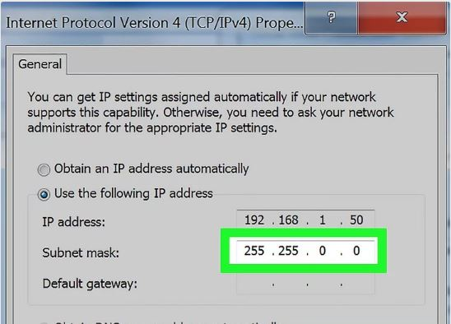
Type 255.255.0.0 into the Subnet mask field.

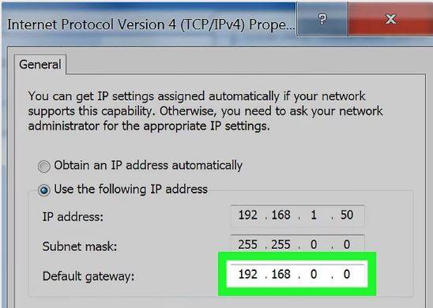
Type 192.168.0.0 into the Default gateway field.
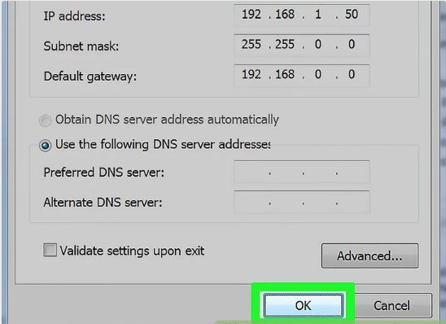

Click OK. This will save the settings for that computer. This computer is now configured on your network with a unique IP address.
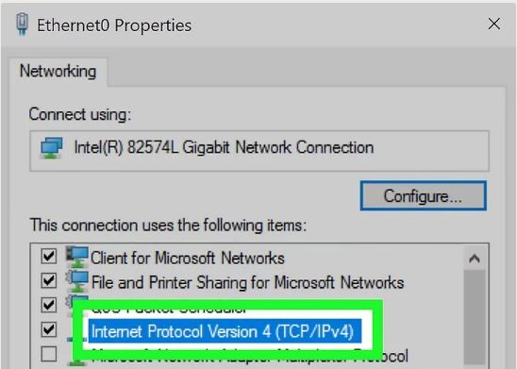

Open the Internet Protocol Version 4 properties on the next computer.Follow the steps above on the second computer to open the Internet Protocol Version 4 (TCP/IPv4) Properties window.

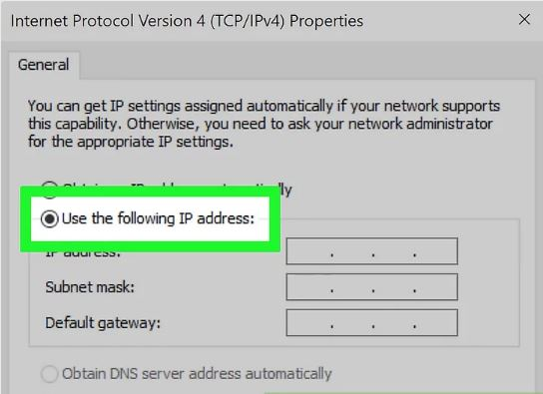

Click the Use the following IP address radio button.

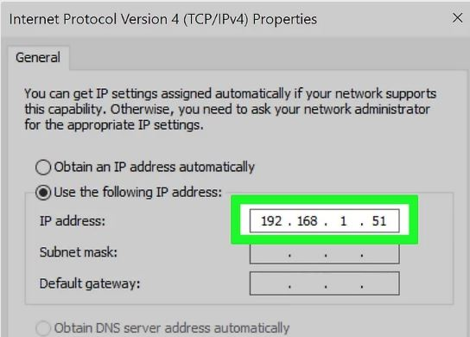

Type 192.168.1.51 into the IP address field. Notice that the final group of numbers has incremented by 1.

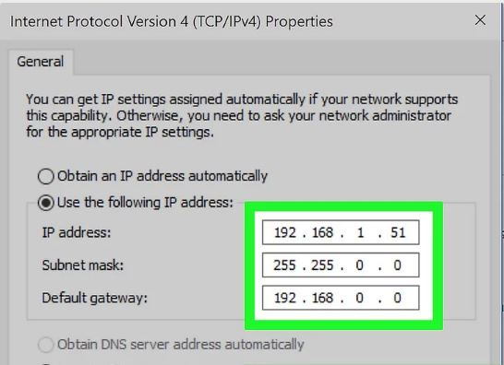

Enter the same values for Subnet mask and Default gateway. These values should be the same as they were on the first computer (255.255.0.0 and 192.168.0.0 respectively).

Viva Questions:

- What is the difference between a public and private IP address?
- A combination of hardware and software which links two parts of the same LAN or two compatible LANs by directing messages to the correct node is called.
- What are the ranges of Class A, Class B, Class C, Class D and Class E.
- Mention the starting address of Class A, Class B, Class C, Class D and Class E.
- Mention the ending address of Class A, Class B, Class C, Class D and Class E.
- Mention the addresses per network of Class A, Class B, Class C, Class D and Class E.
- Mention the number of networks of Class A, Class B, Class C, Class D and Class E.
- How many net id bits and host id bits in Class A, Class B, Class C, Class D and Class E.

EXPERIMENT- 4

OBJECTIVE
Write a program to implement various types of error correcting techniques.

PROGRAM:
#include<iostream>
using namespace std;
int main()
{
int a[10],b[10],c1,c2,c3;
cout<<"\nEnter the 4 bits"; cin>>a[3];
cin>>a[5]; cin>>a[6]; cin>>a[7];
a[1]=a[3]^a[5]^a[7];
a[2]=a[3]^a[6]^a[7];
a[4]=a[5]^a[6]^a[7];
for(int i=1;i<8;i++)
cout<<"\t"<<a[i]; cout<<"\nEnter the 7 bits"; for(int i=1;i<8;i++)
{
cin>>b[i];
}
c1=b[1]^b[3]^b[5]^b[7];
c2=b[2]^b[3]^b[6]^b[7];
c3=b[4]^b[5]^b[6]^b[7];
int p=c1*1+c2*2+c3*4; if(p==0)
{

cout<<"\nThere is No error in the data";
}
else
{
cout<<"\nThere is error in the position "<<p;
if(b[p]==0)
b[p]=1;
else
b[p]=0;
for(int i=1;i<8;i++)
cout<<"\n"<<b[i];
}
return 0;}

OUTPUT

Enter 4 bits of data one by one
1
0
1
0
Encoded data is
1010010
Enter received data bits one by one
1
0
1
0
0
1
0
No error while transmission of data

Viva Questions:
- Differentiate between single bit error, multiple bit error and burst bit error.
- How CRC is different from checksum.
- What is Hamming code correction method?
- How can you perform access control in Data Link Layer?
- How can you perform flow control in Data Link Layer?

EXPERIMENT-5

OBJECTIVE
Write a program to implement various types of framing methods.

PROGRAM
#include<stdio.h>
int main()
{
int i=0,count=0;
char databits[80];
printf("Enter Data Bits: ");
scanf("%s",databits);
printf("Data Bits Before Bit Stuffing:%s",databits);
printf("\nData Bits After Bit stuffing :");
for(i=0; i<strlen(databits); i++)
{
if(databits[i]=='1')
count++;
else
count=0;
printf("%c",databits[i]);
if(count==5)
{
printf("0");
count=0;
}
}
return 0;
}
Output of the Program:
Enter Data Bits: 101111111000
Data Bits Before Bit Stuffing: 101111111000
Data Bits After Bit Stuffing : 1011111011000

Viva Questions:
- What is the purpose of framing in the networking?
- Mention the elements of frame.
- Differentiate between bit stuffing and byte stuffing.
- What is FRAD in frame relay network?
- What are the methods of framing.

EXPERIMENT-6

OBJECTIVE
Write two programs in C: hello_client and hello_server
a. The server listens for, and accepts, a single TCP connection; it reads all the data it can from that connection, and prints it to the screen; then it closes the connection
b. The client connects to the server, sends the string “Hello, world!”, then closes the connection

PROGRAM

- /* CLIENT PROGRAM FOR TCP CONNECTION */

#include <stdio.h>
#include <stdlib.h>
#include <unistd.h>
#include <string.h>
#include <sys/types.h>
#include <sys/socket.h>
#include <netinet/in.h>
#include <netdb.h>

void error(const char *msg)

{
perror(msg);
exit(0);

}

int main(intargc, char *argv[])

{
intsockfd, portno, n;
structsockaddr_inserv_addr;
structhostent *server;
char buffer[256];

if (argc< 3)
{
fprintf(stderr,"usage %s hostname port\n", argv[0]);
exit(0);

}
portno = atoi(argv[2]);
sockfd = socket(AF_INET, SOCK_STREAM, 0);

if (sockfd< 0)
error("ERROR opening socket");

server = gethostbyname(argv[1]);

if (server == NULL)
{

fprintf(stderr,"ERROR, no such host\n");
exit(0);

}
bzero((char *) &serv_addr, sizeof(serv_addr));
serv_addr.sin_family = AF_INET;
bcopy((char *)server->h_addr,char *)&serv_addr.sin_addr.s_addr,
server->h_length);
serv_addr.sin_port = htons(portno);
if(connect(sockfd,(structsockaddr *) &serv_addr,sizeof(serv_addr)) < 0)

error("ERROR connecting");

printf("Please enter the message: ");
bzero(buffer,256);
fgets(buffer,255,stdin);
n = write(sockfd,buffer,strlen(buffer));

if (n < 0)

error("ERROR writing to socket");

bzero(buffer,256);
n = read(sockfd,buffer,255);
if (n < 0)
error("ERROR reading from socket");

printf("%s\n",buffer);
close(sockfd);
return 0;

}
TO RUN-
$ gcc –o client helloclient.c
$ ./client localhostportno
OUTPUT
Please enter the message: I m client
I got your message

/* SERVER PROGRAM FOR TCP CONNECTION*/
#include <stdio.h>
#include <stdlib.h>
#include <string.h>
#include <unistd.h>
#include <sys/types.h>
#include <sys/socket.h>
#include <netinet/in.h>

void error(const char *msg)
{
perror(msg);
exit(1);
}

int main(intargc, char *argv[])
{
intsockfd, newsockfd, portno;
socklen_tclilen;
char buffer[256];
structsockaddr_inserv_addr, cli_addr;
int n;
if (argc< 2) {
fprintf(stderr,"ERROR, no port provided\n");
exit(1);
}
sockfd = socket(AF_INET, SOCK_STREAM, 0);
if (sockfd< 0)
error("ERROR opening socket");
bzero((char *) &serv_addr, sizeof(serv_addr));
portno = atoi(argv[1]);
serv_addr.sin_family = AF_INET;
serv_addr.sin_addr.s_addr = INADDR_ANY;
serv_addr.sin_port = htons(portno);
if (bind(sockfd, (structsockaddr *) &serv_addr,
sizeof(serv_addr)) < 0)
error("ERROR on binding");
listen(sockfd,5);
clilen = sizeof(cli_addr);
newsockfd = accept(sockfd,
(structsockaddr *) &cli_addr,
&clilen);
if (newsockfd< 0)
error("ERROR on accept");
bzero(buffer,256);
n = read(newsockfd,buffer,255);
if (n < 0) error("ERROR reading from socket");
printf("Here is the message: %s\n",buffer);
n = write(newsockfd,"I got your message",18);
if (n < 0) error("ERROR writing to socket");
close(newsockfd);
close(sockfd);
return 0;
}
To RUN-
$ gcc –o server helloserver.c
$ ./server portno
OUTPUT
Here is the message: I’m client

Viva Questions:
- Draw the diagram of three way handshake for TCP connection establishment.
- How can you create TCP socket.
- How can you bind the socket to the server address?
- Mention the use of listen() method in TCP connection.
- Mention the use of accept() method in TCP connection.

EXPERIMENT- 7

OBJECTIVE
Write an Echo_Client and Echo_server using TCP to estimate the round trip time from client to the server. The server should be such that it can accept multiple connections at any given time.

PROGRAM

//Echo server
#include <sys/types.h>
#include <sys/socket.h>
#include <netdb.h>
#include <stdio.h>
#include<string.h>
int main()
{

charstr[100];
intlisten_fd, comm_fd;

structsockaddr_inservaddr;

listen_fd = socket(AF_INET, SOCK_STREAM, 0);

bzero(&servaddr, sizeof(servaddr));

servaddr.sin_family = AF_INET;
servaddr.sin_addr.s_addr = htons(INADDR_ANY);
servaddr.sin_port = htons(22000);

bind(listen_fd, (structsockaddr *) &servaddr, sizeof(servaddr));

listen(listen_fd, 10);
comm_fd = accept(listen_fd, (structsockaddr*) NULL, NULL);

while(1)
{

bzero(str, 100);

read(comm_fd,str,100);

printf("Echoing back - %s",str);

write(comm_fd, str, strlen(str)+1);

}
}

To Run:
$ gcc –o server echoserver.c
$ ./server

Output:

Output:
Echoing back – Hello
Echoing back – How r u
Echoing back – I m fine
Echoing back – Bye

//Client process
#include <sys/types.h>
#include <sys/socket.h>
#include <netdb.h>
#include <stdio.h>
#include<string.h>
int main(intargc,char **argv)
{
intsockfd,n;
charsendline[100];
charrecvline[100];
structsockaddr_inservaddr;

sockfd=socket(AF_INET,SOCK_STREAM,0);
bzero(&servaddr,sizeofservaddr);

servaddr.sin_family=AF_INET;
servaddr.sin_port=htons(22000);

inet_pton(AF_INET,"127.0.0.1",&(servaddr.sin_addr));

connect(sockfd,(structsockaddr *)&servaddr,sizeof(servaddr));

while(1)
{
bzero(sendline, 100);
bzero(recvline, 100);
fgets(sendline,100,stdin); /*stdin = 0 , for standard input */

write(sockfd,sendline,strlen(sendline)+1);
read(sockfd,recvline,100);
printf("%s",recvline);
}

}
To Run:
$ gcc –o client client1.c
$ ./client 22000
OUTPUT
Hello
Hello
How r u
How r u
I m fine
I m fine
Bye
Bye

Viva Questions:
- In which conditions we used TCP protocol.
- How can you create socket file descriptor?
- Why we include sys/socket.h header file.
- Why we include arpa/inet.h header file.
- Why we use memset() function.

EXPERIMENT-8

OBJECTIVE
Write a program in C: hello_client (The server listens for, and accepts, a single UDP connection; it reads all the data itcan from that connection, and prints it to the screen; then it closes the connection)

PROGRAM
// UDP Client
#include<sys/types.h>
#include<sys/socket.h>
#include<netinet/in.h>
#include<arpa/inet.h>
#include<string.h>
#include<stdio.h>
#include<stdlib.h>
#include<unistd.h>

#define MAX_BUF 100

intmain(intargc,char*argv[])
{
intsockd;
structsockaddr_inmy_addr,srv_addr;
charbuf[MAX_BUF];
int count;
intaddrlen;

if(argc<3)
{
fprintf(stderr,"Usage: %s ip_addressport_number\n",argv[0]);
exit(1);
}
/* create a socket */
sockd=socket(AF_INET, SOCK_DGRAM,0);
if(sockd==-1)
{
perror("Socket creation error");
exit(1);
}

/* client address */
my_addr.sin_family= AF_INET;
my_addr.sin_addr.s_addr= INADDR_ANY;
my_addr.sin_port=0;

bind(sockd,(structsockaddr*)&my_addr,sizeof(my_addr));

strcpy(buf,"Hello world\n");

/* server address */
srv_addr.sin_family= AF_INET;
inet_aton(argv[1],&srv_addr.sin_addr);
srv_addr.sin_port=htons(atoi(argv[2]));

sendto(sockd,buf,strlen(buf)+1,0,
(structsockaddr*)&srv_addr,sizeof(srv_addr));

addrlen=sizeof(srv_addr);
count=recvfrom(sockd,buf, MAX_BUF,0,
(structsockaddr*)&srv_addr,&addrlen);
write(1,buf, count);

close(sockd);
return0;

Viva Questions:
- Write down the syntax of recvfrom() function.
- What down the syntax of sendto() function.
- What is bzero function what its utility.
- In which conditions we use UPD connection.
- What is roundtrip time.

EXPERIMENT-9

OBJECTIVE

Repeat Exercise 7 with multiplexed I/O operations.

PROGRAM
//UDP Server
#include<sys/types.h>
#include<sys/socket.h>
#include<netinet/in.h>
#include<arpa/inet.h>
#include<string.h>
#include<stdio.h>
#include<stdlib.h>
#include<unistd.h>

#define MAX_BUF 1024

intmain(intargc,char*argv[])
{
intsockd;
structsockaddr_inmy_name,cli_name;
charbuf[MAX_BUF];
int status;
intaddrlen;

if(argc<2)
{
fprintf(stderr,"Usage: %s port_number\n",argv[0]);
exit(1);
}
/* create a socket */
sockd=socket(AF_INET, SOCK_DGRAM,0);
if(sockd==-1)
{
perror("Socket creation error");
exit(1);
}

/* server address */
my_name.sin_family= AF_INET;
my_name.sin_addr.s_addr= INADDR_ANY;
my_name.sin_port=htons(atoi(argv[1]));

status=bind(sockd,(structsockaddr*)&my_name,sizeof(my_name));

addrlen=sizeof(cli_name);
status=recvfrom(sockd,buf, MAX_BUF,0,
(structsockaddr*)&cli_name,&addrlen);

printf("%s",buf);
strcat(buf,"OK!\n");

status=sendto(sockd,buf,strlen(buf)+1,0,
(structsockaddr*)&cli_name,sizeof(cli_name));

close(sockd);
return0;
}

Echoing back – Hello
Echoing back – How r u
Echoing back – I m fine
Echoing back – Bye

//Client process
#include <sys/types.h>
#include <sys/socket.h>
#include <netdb.h>
#include <stdio.h>
#include<string.h>
int main(intargc,char **argv)
{
intsockfd,n;
charsendline[100];
charrecvline[100];
structsockaddr_inservaddr;

sockfd=socket(AF_INET,SOCK_STREAM,0);
bzero(&servaddr,sizeofservaddr);

servaddr.sin_family=AF_INET;
servaddr.sin_port=htons(22000);

inet_pton(AF_INET,"127.0.0.1",&(servaddr.sin_addr));

connect(sockfd,(structsockaddr *)&servaddr,sizeof(servaddr));

while(1)
{
bzero(sendline, 100);
bzero(recvline, 100);
fgets(sendline,100,stdin); /*stdin = 0 , for standard input */

write(sockfd,sendline,strlen(sendline)+1);
read(sockfd,recvline,100);
printf("%s",recvline);
}

}
To Run:
$ gcc –o client client1.c
$ ./client 22000
Output:
Hello
Hello
How r u
How r u
I m fine
I m fine
Bye
Bye

Viva Questions:
- Write down the syntax of recvfrom() function.
- What down the syntax of sendto() function.
- What is bzero function what its utility.
- In which conditions we use UPD connection.
- What is roundtrip time.

EXPERIMENT-10

OBJECTIVE

Simulate Bellman-Ford Routing algorithm in NS2.

Program:

#include <stdio.h>

typedefstruct {
int u, v, w;
} Edge;

int n; /* the number of nodes */
int e; /* the number of edges */
Edge edges[1024]; /* large enough for n <= 2^5=32 */
int d[32]; /* d[i] is the minimum distance from node s to node i */

#define INFINITY 10000

voidprintDist() {
int i;

printf("Distances:\n");

for (i = 0; i < n; ++i)
printf("to %d\t", i + 1);
printf("\n");

for (i = 0; i < n; ++i)
printf("%d\t", d[i]);

printf("\n\n");
}

voidbellman_ford(int s) {
int i, j;

for (i = 0; i < n; ++i)
d[i] = INFINITY;

d[s] = 0;

for (i = 0; i < n - 1; ++i)
for (j = 0; j < e; ++j)
if (d[edges[j].u] + edges[j].w < d[edges[j].v])
d[edges[j].v] = d[edges[j].u] + edges[j].w;
}

int main(intargc, char *argv[]) {
int i, j;
int w;

FILE *fin = fopen("dist.txt", "r");
fscanf(fin, "%d", &n);
e = 0;

for (i = 0; i < n; ++i)
for (j = 0; j < n; ++j) {
fscanf(fin, "%d", &w);
if (w != 0) {
edges[e].u = i;
edges[e].v = j;
edges[e].w = w;
++e;
}
}
fclose(fin);
/* printDist(); */
bellman_ford(0);
printDist();
return 0;
}
OUTPUT
And here’s the input file used in the example (dist.txt):
5
0 6 0 7 0
0 0 5 8 -4
0 -2 0 0 0
0 0 -3 9 0
2 0 7 0 0

Viva Questions

What is the time complexity of Bellman form algorithm?

How Bellman ford algorithm is different from Dijkastra algorithm.

How Bellman ford algorithm is different from Warshalls algorithm.

Mention the time complexity of Bellman Ford Algorithm.

How can you drive the complexity of Bellman Ford Algorithm.

BEYOND THE SYLLABUS

EXPERIMENT-1

OBJECTIVE
Construct a network of hub and switch using Packet Tracer.

Step 1:
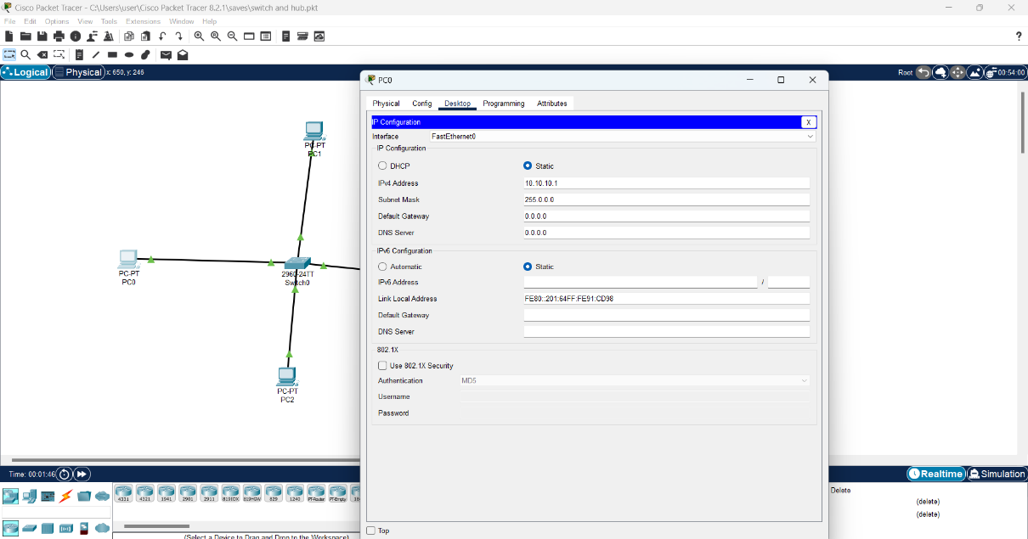
Step 2:
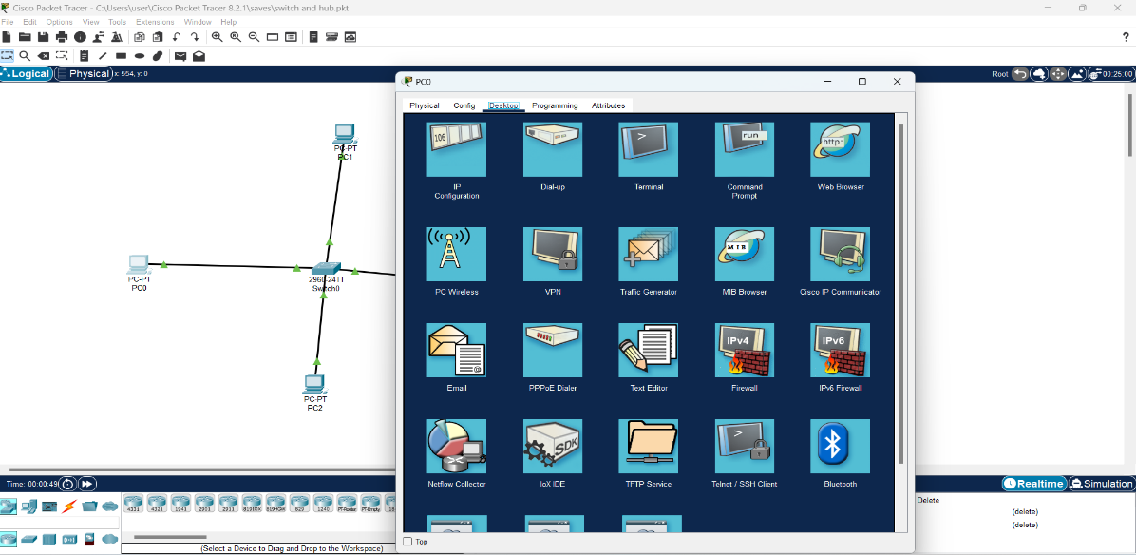

Step 3:
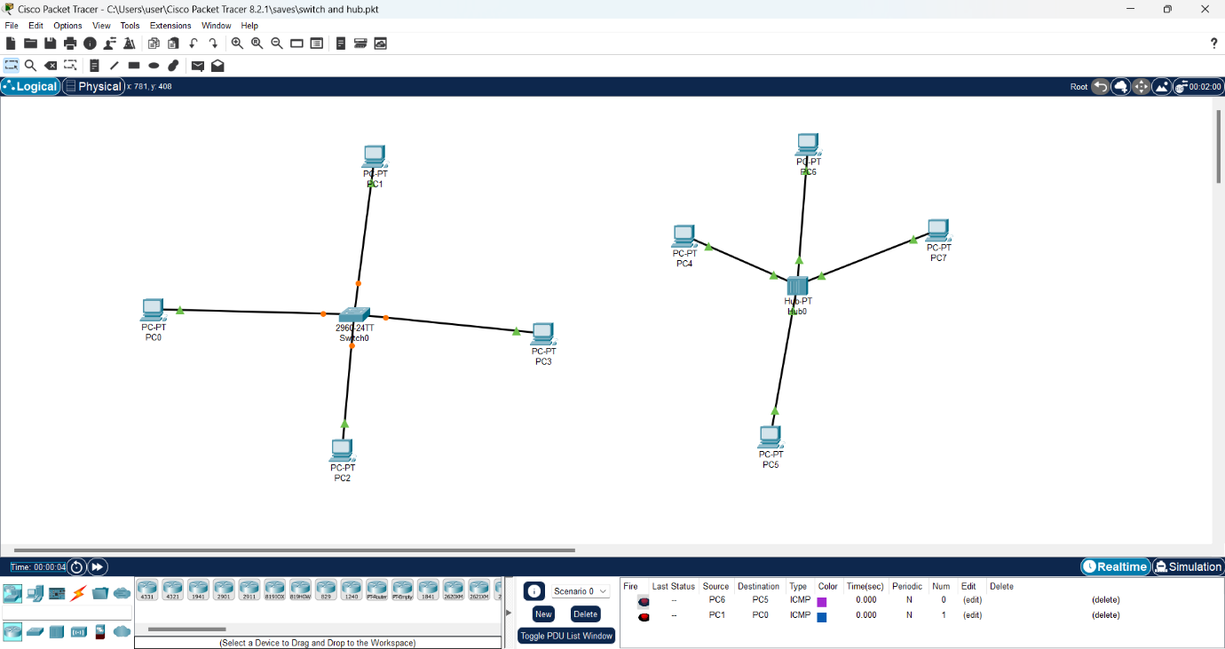
Step 4:
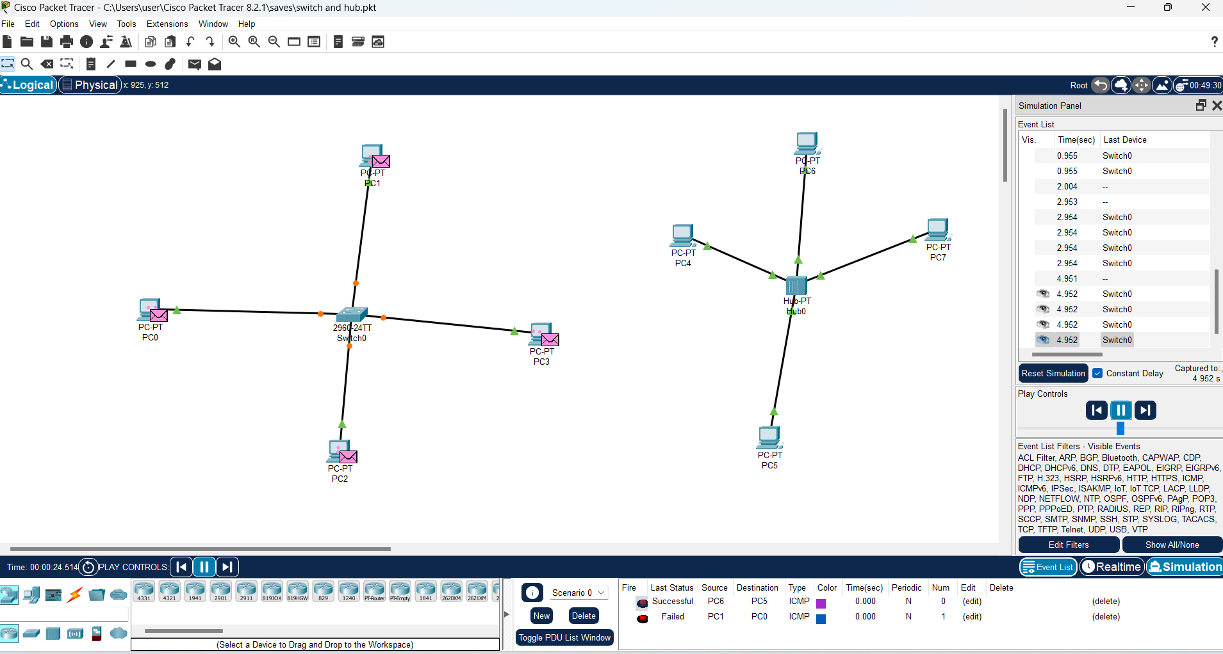

Viva Questions:
    - In which OSI layer hub is used ?
    - In which OSI layer switch is used ?
    - Why switch is more intelligent as compare with hub?
    - How we attach two systems in packet tracer?
    - How can you give IP address in packet tracer and after it how can you check connectivity between the systems.

BEYOND THE SYLLABUS

EXPERIMENT-2

OBJECTIVE

Construct a network of Mesh topolgy using Packet Tracer.

Step 1:

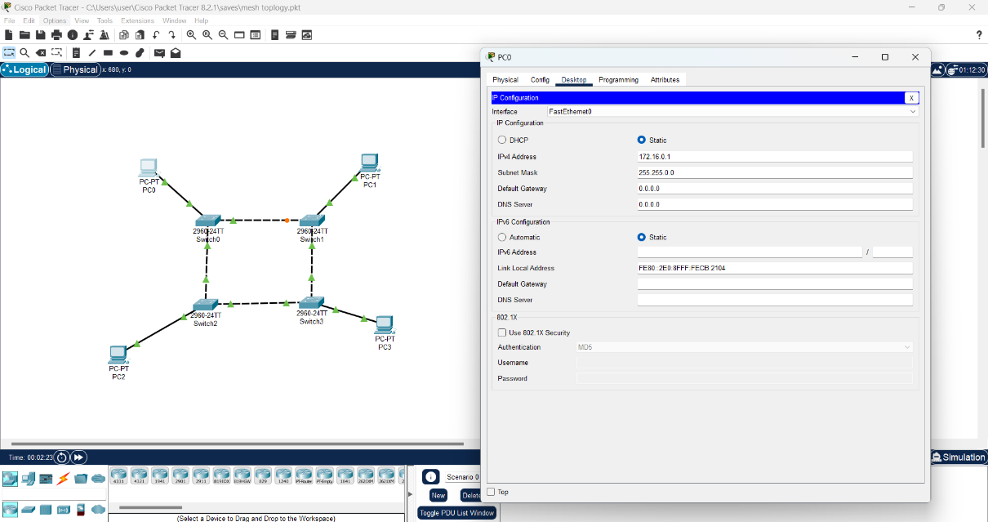

Step 2:

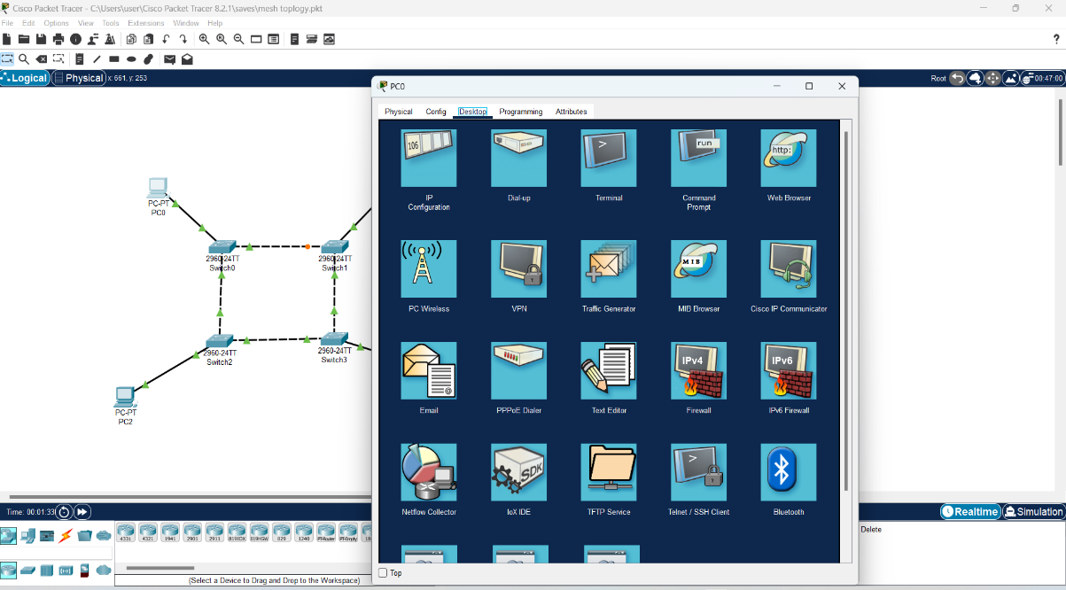

Step 3:

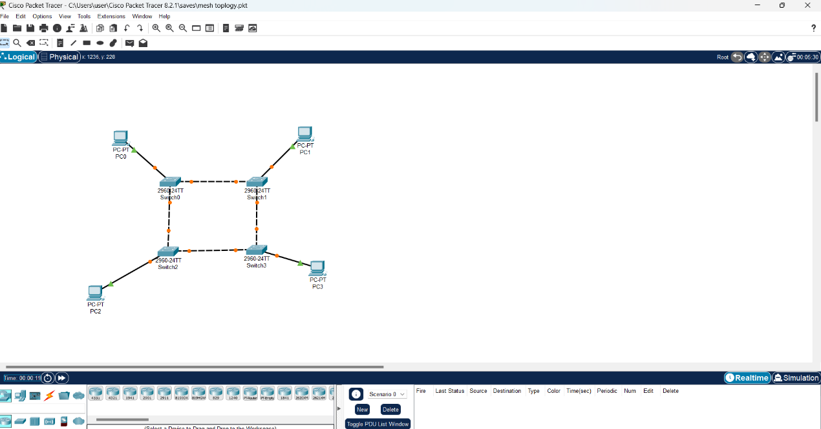

Step 4:

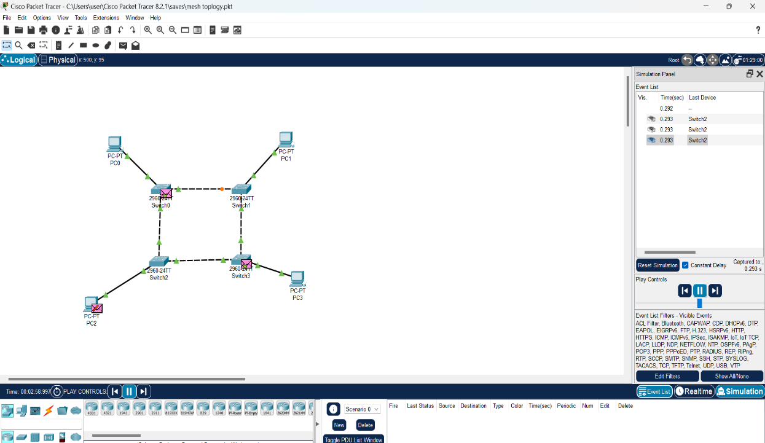

Viva Questions:

If there are m systems how many cables will required in mesh topology to connect them.

How mesh is different from star topology.

What are the advantages of mesh topology.

What are the steps to build a mesh network in packet tracer.

How can you check whether two systems are connected with each other or not.

